

numerical analysis

Lab 2



Muhammad Roshan Mughees

193590

CS-6A

Task 1:

**For range -3 to -2**

x=-3:.01:-2;

f1 = 2*x.*cos(2*x);

f2 = (x+1).^2;

plot(x,f1)

hold on

plot(x,f2)

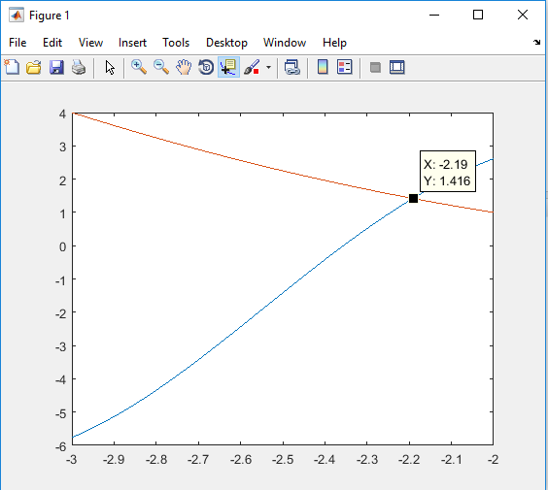

**For roots:**

p = @(x) 2*x.*cos(2*x)-(x+1).^2;

z= fzero(p,[-3 -2])

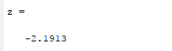

**For range -1 to 0**

x=-1:.01:0;

f1 = 2*x.*cos(2*x);

f2 = (x+1).^2;

plot(x,f1)

hold on

plot(x,f2)

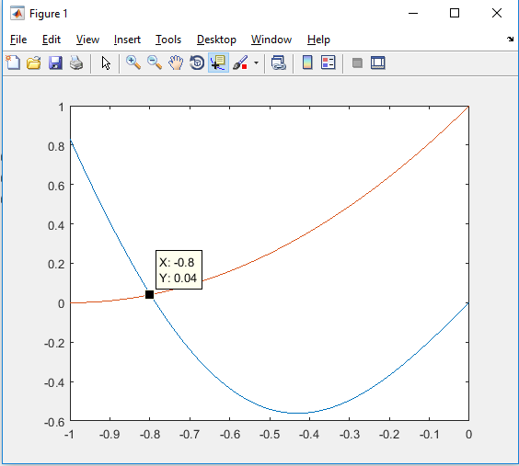

**For roots:**

p = @(x) 2*x.*cos(2*x)-(x+1).^2;

z= fzero(p,[-1 0])

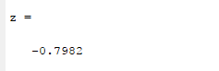

Task 2:

syms x;

P1=taylor(cos(x),'ExpansionPoint',0,'Order',3);

P2=taylor(cos(x),'ExpansionPoint',0,'Order',5);

P3=taylor(cos(x),'ExpansionPoint',0,'Order',7);

fplot([cos(x) P1 P2P3])

